

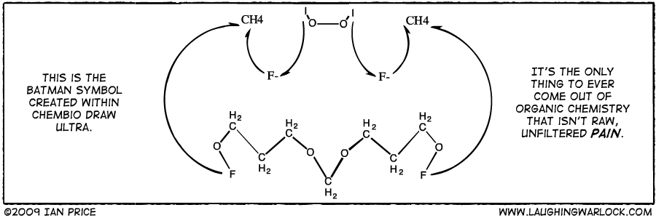
Properties and Structure of Organic Materials

(Yuku 2013)
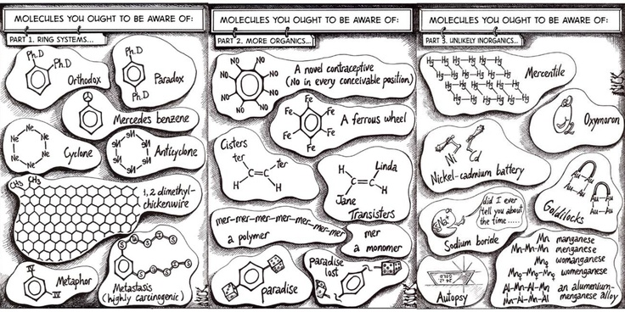
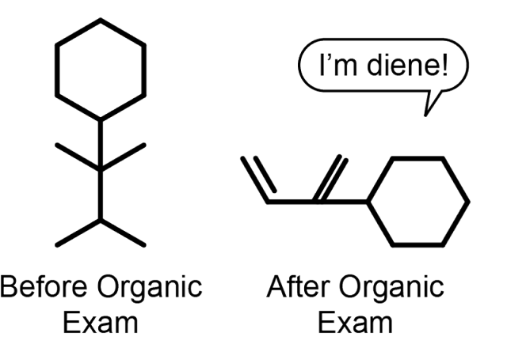

(Helmenstine 2015)
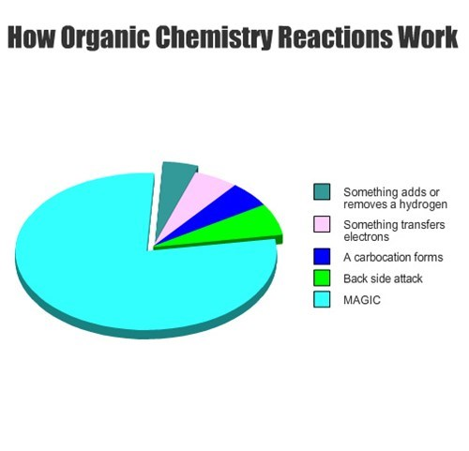

(Swimm n.d.)

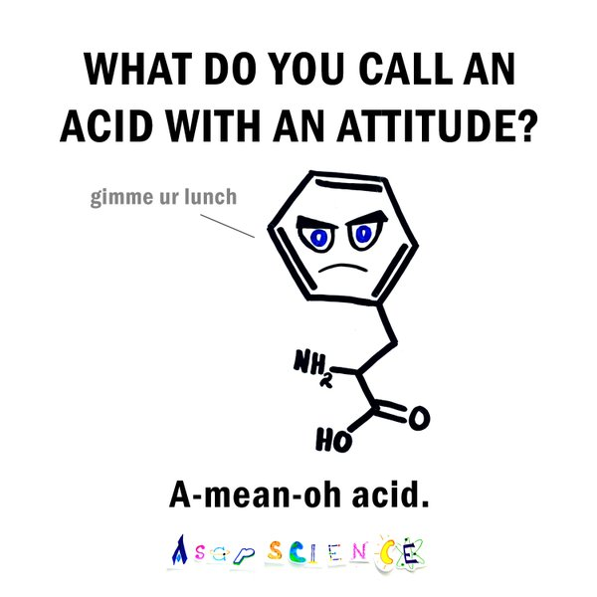

(Ehingers 2014)
(Moffit 2012)
Week | topic | unit content | assessment
18 | Investigation | - Vitamin C Content of Juice | Investigation
19 – 23 | Properties and Structure of Organic Materials | - organic molecules have a hydrocarbon skeleton and can contain functional groups, including alkenes, alcohols, aldehydes, ketones, carboxylic acids, esters, amines and amides; functional groups are groups of atoms or bonds within molecules which are responsible for the molecule’s characteristic chemical properties  - structural formulae (condensed or showing bonds) can be used to show the arrangement of atoms and bonding in organic molecules that contain the following functional groups: alkenes, alcohols, aldehydes, ketones, carboxylic acids, esters, amines and amides  - functional groups within organic compounds display characteristic chemical properties and undergo specific reactions; these reactions include addition reactions of alkenes, redox reactions of alcohols, and acid-base reactions of carboxylic acids; these reactions can be used to identify the functional group present within the organic compound  - IUPAC nomenclature is used to name organic species, including those with a parent chain of up to 8 carbon atoms with simple branching and one of the following functional groups: alkenes, alcohols, aldehydes, ketones, carboxylic acids, esters, amines and amides  - isomers are compounds with the same molecular formulae but different structures; different types of isomerism include chain and position structural isomerism and cis-trans isomerism  - all alcohols can undergo complete combustion; with oxidising agents, including acidified MnO₄‒ or Cr₂O₇²⁻ oxidation of primary alcohols produces aldehydes and carboxylic acids, while the oxidation of secondary alcohols produce ketones; these reactions have characteristic observations and can be represented with equations  - alcohols can react with carboxylic acids in a condensation reaction to produce esters and can be represented with equations  - organic compounds display characteristic physical properties, including boiling point and solubility in water and organic solvents; these properties can be explained in terms of intermolecular forces (dispersion forces, dipole-dipole interactions and hydrogen bonds) which are influenced by the nature of the functional groups  - empirical and molecular formulae can be determined by calculation and the structure of an organic compound established from the chemical reactions they undergo, and other analytical data  - addition reactions can be used to produce polymers, including polyethene and polytetrafluoroethene  - the structure of an addition polymer can be predicted from its monomer and the structure of an addition polymer can be used to predict the monomer from which it was derived  - condensation reactions can be used to produce polymers, including polyamides and polyesters  - the structure of a condensation polymer can be predicted and drawn from its monomer(s) and the structure of a condensation polymer can be used to predict the monomer(s) from which it was derived  - α-amino acids can be represented using a generalised structure  - the characteristic properties of α-amino acids include the formation of zwitterions and the ability to react to form amide (peptide) bonds through condensation reactions  - α-amino acids undergo condensation reactions to form polypeptides (proteins) in which the α-amino acid monomers are joined by peptide bonds  - the sequence of α-amino acids in a protein is called its primary structure  - secondary structures of proteins, (α-helix and β-pleated sheets) result from hydrogen bonding between amide and carbonyl functional groups; hydrogen bonding between amide and carbonyl functional groups within a peptide chain leads to α-helix structures while hydrogen bonding between adjacent polypeptide chains leads to β-pleated sheets  - the tertiary structure of a protein (the overall three-dimensional shape) is a result of folding due to interactions between the side chains of the α-amino acid in the polypeptide, including disulfide bridges, hydrogen bonding, dipole-dipole interactions, dispersion forces and ionic interactions  - The Protein Data Bank (PDB) houses an international repository of structural data of proteins. The information is accessed and contributed to by scientists worldwide. The function of a protein is closely linked to its structure. | Practical 4  Test 4

Organic Chemistry
Hydrocarbons are molecular compounds containing the elements hydrogen and carbon. They are classified into various families of compounds based on structural similarities.

Nomenclature (Naming)
- Find the longest continuous carbon chain. Choose the stem name based on the number of carbon atoms in the longest continuous carbon chain.

Number of Carbons | Stem Name
One
Two
Three
Four
Five
Six
Seven
Eight
Nine
Ten

- Number the carbon atoms sequentially so that the principle functional group has the lowest number.
The order of priority of the principle functional groups is (from highest to lowest): carboxylic acid (-COOH), ester (-COO-), amide (-CONH₂), aldehyde (-CHO), ketone (-CO-), alcohol(-OH), amine (-NH₂), alkene (-C=C-), haloalkane (-CX) and alkane.

For example:

- If there is a functional group, number the carbons from the end which gives the lowest number to the functional group. The functional group dictates the stem name.
For example:

- If there is an alkyl group (other carbon atoms not part of the main chain – also called a branch), name this using the stem name for the number of carbons and use the suffix ______. Put a number in front to indicate which carbon it comes from then write the stem name.
For example: -CH₃ methyl-
-CH₂CH₃ ethyl-

- If there is more than one of a substituted group, write the numbers to indicate which carbon they come off, then follow with the prefix di, tri, tetra, penta, etc, then the branch name and -yl. Always finish with the straight chain name.
For example:

- Note that numbers are separated from words by hyphens and numbers are separated from each other by commas. There should be no spaces or capital letters in the name at all (unless it is the beginning of a sentence).

- If there are different types of alkyl groups in the same chain, again use numbers, and put the alkyl groups in alphabetical order according to the stem name (note: you disregard the numerical prefix when alphabetizing).

For example:

- If there are substituted halogens, the same rules apply as for alkyl groups, but use fluoro-, chloro-, bromo- and/or iodo-. If the substituted group is -OH use ___________________ and if it is -NH₂ use _______________. Again, substituted groups are named alphabetically.
For example:

- If there is only one option for a substituted halogen, hydroxy, amino or alkyl groups, do not use numbers.
For example:

Alkanes
- General formula: _________________
- Molecules contain single bonds only and are saturated.
- Names end with the suffix ________.
- Structural isomers exist where they have the same molecular formula but different structures. Chain isomers exist when the main chain length is changed and positional isomers exist when the position of a branch changes

For example: C₄H₁₀

- Intermolecular force present in alkanes _________________________________________ ________________________________________________________________________. Dispersion forces are weak intermolecular forces that occur in non-polar species due to the formation of temporary dipoles which then induce temporary dipoles in the surrounding species.

- The longer the alkane, ______________________________________________________ ________________________________________________________________________. Straight chain alkanes possess stronger dispersion forces than branched alkanes as their shape allows maximum surface contact between the molecules.

- Increased dispersion forces result in higher melting and boiling points.

Compound | Melting Point (°C) | Boiling Point (°C)
propane | -187.7 | - 42.25
butane | -140.0 | -1.0
pentane | -129.1 | 35.9
methylbutane | -161.0 | 27.8

- Alkanes are ______________________________________________________________. In order for a substance to be soluble in another substance the intermolecular forces formed between the solute and solvent must be equal to or stronger (energetically) than the solute-solute and solvent-solvent intermolecular forces. In the case of alkanes, the dispersion forces present in the alkane are not strong enough to overcome the hydrogen bonding present in water but will dissolve in non-polar substances such as oil.

- Alkanes undergo _________________________. Typical example is halogenation reaction.
For example:

Alkenes
- General formula: ______________
- Molecules contain a double bond and are unsaturated.
- Names end with the suffix _______________.
- When numbering, the longest continuous chain must include the double bond.
- Cis/trans (geometric) isomers exist where they have the same molecular and structural formula but different spatial arrangement of the atoms about the double bond (due to the inability of rotation to occur around a double bond). Cis/trans isomerism can only exist if both carbon atoms on the double bond have two different groups attached. If cis/trans isomerism is present, this is indicated by including either cis- or trans- at the beginning of the compounds name.

- The intermolecular force present in alkenes is ________________________ and their melting and boiling points tend to be slightly lower than their counterpart alkanes due to their stereochemistry.

Compound | Melting Point (°C) | Boiling Point (°C)
propene | -188.2 | - 47.6
but-1-ene | -185.0 | - 6.7
pent-1-ene | -165.2 | 30.0

- Alkenes undergo ____________________ where two atoms are added across the double bond (converting it to a single bond). Reactions include:
  - Hydrogenation – reaction with hydrogen gas and a Ni, Pt or Pd catalyst.
eg.

  - Halogenation – reaction with a halogen. This is a classic chemical test to distinguish an alkene from other organic compounds.
eg.

  - Hydrohalogenation – reaction with a hydrogen halide. In this case Markovnikov’s rule may need to be followed (the hydrogen will be added to the carbon across the double bond that already possesses the most hydrogens. If both carbons have the same number of hydrogens, a 50/50 mixture of both possible compounds will be produced).
eg.

  - Hydration – reaction with water (Markovnikov’s rule comes into play).
eg.

Complete Lucarelli Set 15 Organic Chemistry: Alkanes and Alkenes

Alcohols
- Contain the functional group _______________________
- Names end with the suffix ___________.
General formula:
For example:

- Can be classified as primary (1°), secondary (2°)or tertiary (3°) alcohols based on the number of other carbons the -OH carbon is bonded to.
eg.

1° 2° 3°
- Intermolecular forces present: ________________________________________________. Hydrogen bonding is an extreme form of dipole-dipole forces that only occurs when a hydrogen atom bonded to a fluorine, oxygen or nitrogen interacts with a non-bonding pair of electrons on another fluorine, oxygen or nitrogen atom (either on the same molecule or from different polar molecules). Hydrogen bonding is due to the highly electronegative negative nature of fluorine, oxygen and nitrogen that have a high charge density due to their relatively small size.
- Melting and boiling points are higher than analogous alkanes due to presence of stronger hydrogen bonding forces (in addition to dispersion forces). As the chain length becomes longer, the melting and boiling points increase as the dispersion forces then “add” to the strength of the overall intermolecular forces taking place between the alcohol molecules.
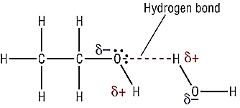

(Larsen n.d.)

- In general, for alcohols of the same size, primary alcohols have higher boiling and melting points than secondary alcohols which have higher boiling and melting points than tertiary alcohols. This is (in essence) due to the exposure of the hydroxyl group.

Alcohol | Boiling Point (ºC)
butan-1-ol | 118
butan-2-ol | 99
methylpropan-2-ol | 82

- Soluble in water and polar molecules due to similar strength of hydrogen bonding in the alcohol and either hydrogen bonding or dipole-dipole bonding in the other substance. The solubility decreases with increasing chain length as dispersion forces become more significant and prevent solvation in polar substances (they then become more soluble in non-polar substances).

Aldehydes
- Contain the functional group __________________________________________________
- Names end with the suffix ________________
General formula:

For example:

- Intermolecular forces present: ________________________________________________. Dipole-dipole forces occur in polar molecules. It is due to the electrostatic attraction between oppositely charged ends of the overall dipole. Although the strength of a dipole moment increases with the increased difference in electronegativities between atoms in a molecule, the dispersion intermolecular force increases with increasing number of electrons (that is, the dispersion forces become more significant and impact the melting and boiling points).

- Melting and boiling points are higher than analogous alkanes due to presence of stronger dipole-dipole forces (in addition to dispersion forces) but lower than analogous alcohols (due to absence of hydrogen bonds). As the chain length becomes longer, the melting and boiling points increase as the dispersion forces then “add” to the strength of the overall intermolecular forces taking place between the aldehyde molecules.

- Soluble in water and polar molecules due to similar strength of dipole-dipole forces in the aldehyde and either hydrogen bonding or dipole-dipole bonding in the other polar substance. The solubility decreases with increasing chain length as dispersion forces become more significant and prevent solvation in polar substances (they then become more soluble in non-polar substances).

Ketones
- Contain the functional group __________________________________________________
- Names end with the suffix ______________.
General formula:
For example:

- Intermolecular forces present: ________________________________________________.

- Melting and boiling points are higher than analogous alkanes due to presence of stronger dipole-dipole bonding forces (in addition to dispersion forces) but lower than analogous alcohols (due to absence of hydrogen bonds) and similar to analogous aldehydes. As the chain length becomes longer, the melting and boiling points increase as the dispersion forces then “add” to the strength of the overall intermolecular forces taking place between the ketone molecules.

- Soluble in water and polar molecules due to similar strength of dipole-dipole bonding in the ketone and either hydrogen bonding or dipole-dipole bonding in the other substance. The solubility decreases with increasing chain length as dispersion forces become more significant and prevent solvation in polar substances (they then become more soluble in non-polar substances).

Carboxylic Acids
- Contain the functional group __________________________________________________
- Names end with the suffix _____________________.
General formula:

For example:

- Intermolecular forces present: ________________________________________________.

- Melting and boiling points are higher than analogous alkanes, aldehydes, ketones and alcohols due to presence of stronger hydrogen bonding and dipole-dipole bonding forces (in addition to dispersion forces). As the chain length becomes longer, the melting and boiling points increase as the dispersion forces then “add” to the strength of the overall intermolecular forces taking place between the carboxylic acid molecules.

- Soluble in water and polar molecules due to similar strength of hydrogen bonding or dipole-dipole bonding in the carboxylic acid and either hydrogen bonding or dipole-dipole bonding in the other substance. The solubility decreases with increasing chain length as dispersion forces become more significant and prevent solvation in polar substances (they then become more soluble in non-polar substances).

Amines
- Contain the functional group ________________________________
- Names end with the suffix _____________________________.
General formula:

For example:

- Intermolecular forces present: _____________________________________________

- Melting and boiling points are higher than analogous alkanes, aldehydes and ketones due to presence of stronger hydrogen bonding forces (in addition to dispersion forces). Melting points and boiling points are lower than analogous carboxylic acids and alcohols (indicating the hydrogen bond strength in alcohols is stronger than the hydrogen bonding in amines). As the chain length becomes longer, the melting and boiling points increase as the dispersion forces then “add” to the strength of the overall intermolecular forces taking place between the amine molecules.

- Soluble in water and polar molecules due to similar strength of hydrogen bonding or dipole-dipole bonding in the amine and either hydrogen bonding or dipole-dipole bonding in the other substance. The solubility decreases with increasing chain length as dispersion forces become more significant and prevent solvation in polar substances (they then become more soluble in non-polar substances).

Amides
- Contain the functional group ___________________________________________
- Names end with the suffix __________________________.
General formula:

For example:

- Intermolecular forces present: ________________________________________________. The hydrogen bonding present in amides is much stronger than analogous amines or carboxylic acids. This is due to a greater number of hydrogen atoms available for hydrogen bonding in an amide compared to an amine or carboxylic acid. Each amide molecule has three lone pairs of electrons and two hydrogen atoms that are available for hydrogen bonding. Also, the close proximity of the highly electronegative oxygen atom causes hydrogen atoms from the NH₂ group to develop a larger dipole (+δ) than would occur on the nitrogen only.
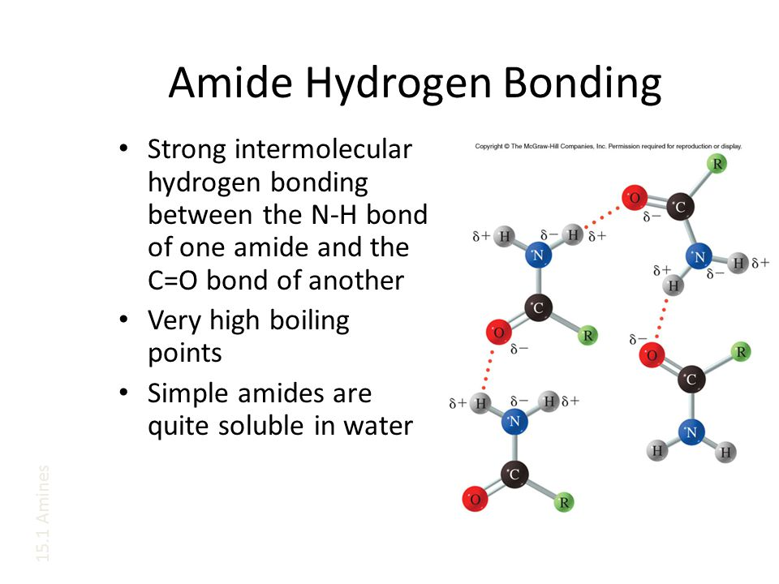

(Iveson n.d.)

- Melting and boiling points are higher than analogous alkanes, aldehydes, ketones, amines, alcohols and carboxylic acids due to presence of stronger hydrogen bonding forces (in addition to dipole-dipole forces and dispersion forces). As the chain length becomes longer, the melting and boiling points increase as the dispersion forces then “add” to the strength of the overall intermolecular forces taking place between the amide molecules.

- Soluble in water and polar molecules due to similar strength of hydrogen bonding or dipole-dipole bonding in the amide and either hydrogen bonding or dipole-dipole bonding in the other substance. The solubility decreases with increasing chain length as dispersion forces become more significant and prevent solvation in polar substances (they then become more soluble in non-polar substances).
Esters
- Contain the functional group __________________________________________________
- Names end with the suffix ___________________________________________________ _________________________________________________________

General formula:

For example:

- Intermolecular forces present: ________________________________________________.

- Melting and boiling points are higher than analogous alkanes, similar to analogous aldehydes and ketones but lower than analogous amines, amides, carboxylic acids and alcohols. As the chain length becomes longer, the melting and boiling points increase as the dispersion forces then “add” to the strength of the overall intermolecular forces taking place between the ester molecules.

- Soluble in water and polar molecules due to similar strength of dipole-dipole forces in the ester and either hydrogen bonding or dipole-dipole bonding in the other substance. The solubility decreases with increasing chain length as dispersion forces become more significant and prevent solvation in polar substances (they then become more soluble in non-polar substances).

- Esters have a characteristic sweet, fruity smell that makes them useful in the food and cosmetic industry.

Amino Acids
- Contain the functional groups -NH₂ and -COOH. α (Alpha) -amino acids have the amino group (-NH₂) attached to the carbon right next to the carboxyl group (-COOH).
General formula:
For example:

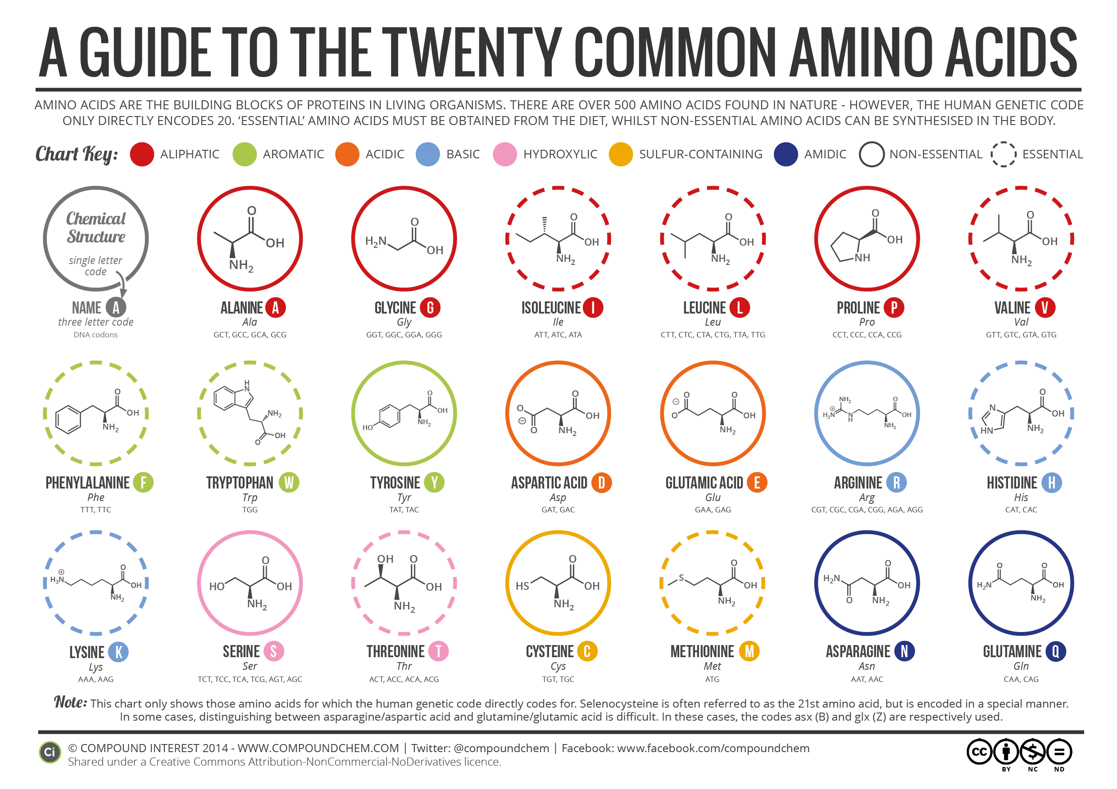

(Creative Commons Attribution-NonCommercial-NoDerivatives 4.0 International License 2014)

- α-amino acids act as monomer and combine to form proteins and polypetides (unbranched polymers)

- In solid state and neutral aqueous solutions they exist as a dipolar ion called a zwitterion (i.e. it has both a positive and negative charge but no net charge). In this form, the carboxyl group gives up an acidic proton (leaving behind anionic -COO‒) which is accepted by the amino group (producing the cationic -NH₃⁺).

- As zwitterions, they possess relatively high melting points (much higher than analogous carboxylic acids, amines, amides, alcohols, etc). This is because they possess ionic bonding.

- The dipolar nature of zwitterions also makes them very soluble in water (interacting through ion-dipole interactions).

- The dipolar nature of zwitterions also allows them to act as acids or bases and can also act as buffers.
In acidic media:

In basic media:

Complete Lucarelli Set 16 Organic Chemistry: Functional Groups

Organic Reactions
- Combustion of organic compounds – react with oxygen to produce carbon dioxide and water in complete combustion and carbon monoxide and water in incomplete combustion (note: this is the only time when you can write the formula of organic compounds as highly condensed formula).
For example:
2C₅H_{10(l)} + 15O_{2(g)} → 10CO_{2(g)} + 10H₂O_{(g)}
C₃H₇COOH_{(l)} + 3O_{2(g limited)} → 4CO_{(g)} + 4H₂O_{(g)}
2C₃H₆O₂(g) + 7O_{2(g)} → 6CO_{2(g)} + 6H₂O_{(g)}

- Oxidation of alcohols – react with oxidising agents such as acidified KMnO_{4(aq)} or acidified K₂Cr₂O_{7(aq)}.
  - Primary alcohols oxidise to produce an aldehyde and then further oxidise to produce a carboxylic acid.
For example:

×3

×3

One step

×3

×2

  - Secondary alcohols oxidise to produce a ketone
For example

×5

×2

  - Tertiary alcohols do not readily oxidise.

Complete Lucarelli Set 16 Organic Chemistry: Redox Reactions

- Acid-base reactions of carboxylic acids – carboxylic acids are weak acids and partially ionise in solution

They also react as typical acids

- Esterification – reaction of an alcohol and a carboxylic acid in the presence of sulfuric acid (it is usually heated to speed up the reaction rate). In this reaction, the carboxylic acid gives away the hydroxyl group (-OH) and the alcohol gives away a hydrogen.
For example:

- Ester hydrolysis – reacting an ester with an hydroxide produces a carboxylate ion and an alcohol
For example:

Complete Lucarelli Set 18 Carboxylic Acids, Esterification and Soaps Questions 1 – 8, 11.

Empirical Formula
- The empirical formula of any compound is the simplest whole number ratio in which the atoms of the elements are present.
- The molecular formula is the actual number of each type of atom present in the molecule.
- The following formula may need to be used (it is on the Chemistry data sheet):
pressure (kPa) × volume (L) = number of moles (mol) × Universal gas constant
(8.314 J K⁻¹ mol⁻¹) × temperature (K) i.e PV = nRT
- You are expected to recognise when to multiply by 2, 3, 4, or 5 when the ratios are not whole numbers

Examples:

A 2.50 g sample of an unknown compound with a molar mass of 201.3 g mol⁻¹ was found to contain 60 % carbon, 8 % hydrogen and 32 % oxygen. Calculate the empirical formula and determine the molecular formula of the compound.

Elementary analysis of an organic compound indicated it that contained only carbon, hydrogen, oxygen and nitrogen. A 1.279 g sample was burnt in oxygen and produced 1.600 g of carbon dioxide and 0.770 g of water. A separate 5.729 g sample was reacted and produced
1.289 L of ammonia gas at 300 K and 105 kPa. Calculate the empirical formula of the compound.

Complete Lucarelli Set 19 Empirical Formula

Macromolecules
Polymers
- Polymers consist of long chains of repeating smaller units called monomers.
- Polymers can consist of long straight chains or they may have side chains that join to other chains (cross linking).
- Two types of polymerisation reactions that lead to the formation of polymers

Addition Polymerisation
- Involves small molecule alkenes acting as monomers and joining up with the use of a catalyst and an initiator. The double bond is broken which results in spare electrons that can pair with spare electrons in the next monomer.
- General reaction given by:

- The polymer is named by adding the prefix poly- to the monomer name (sometimes in brackets). Some polymers have common names that are used more often.

IUPAC Name | Common Name
polyethene
poly(propene)
poly(chloroethene)
poly(1,1,2,2-tetrafluoroethene)
poly(phenylethene)

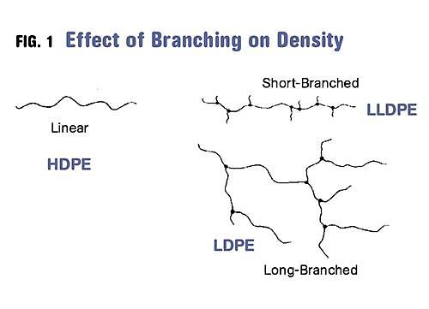
- Depending on the conditions used in its manufacture, polyethylene can either be classified as high density polyethene (HDPE – mostly straight chains with very few side chains resulting in a stronger (greater dispersion forces present), rigid plastic) or low density polyethene (LDPE – side chains are present on the main chain resulting in a softer, flexible plastic).

(Sepe 2012)

Examples:
Draw the addition polymerisation occurring with the following monomers:

H

Determine the monomers that produced the following polymers.

Condensation Polymerisation
- Involves the joining of monomers to produce the polymer and a small molecule such as water (most often) or carbon dioxide. The monomers must have a functional group at either end of the molecule. Monomers can include diols (dialcohols), dicarboxylic acids and diamines or a combination of these functional groups on one monomer.
- The polymers produced can include polyesters and polyamides. .
- General reaction given by:

Examples:
Draw the condensation polymerisation occurring with the following monomers:

+

Determine the monomers that produced the following polymers.

Proteins
- Natural polymers formed through the combination of α-amino acids.
- The link that forms between the amino functional group of one α-amino acid and the carboxylic acid functional group of another α-amino acid is called a peptide link.

- When two α-amino acids combine, the resulting structure is sometimes referred to as a dipeptide.
- If more α-amino acids then add to the dipeptide, it is referred to as a polypeptide. In general, if more than fifty α-amino acids are present in a peptide chain, it is referred to as a protein.
- When writing the structure of proteins it is common to begin (on the left) with a N-terminus (-NH₂ group) and end (on the right) with a C-terminus (-COOH group).

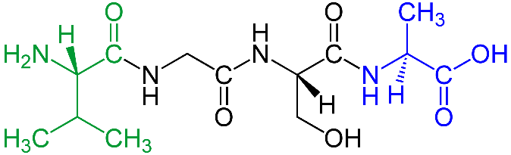

Val-Gly-Ser-Ala (Ju 2010)

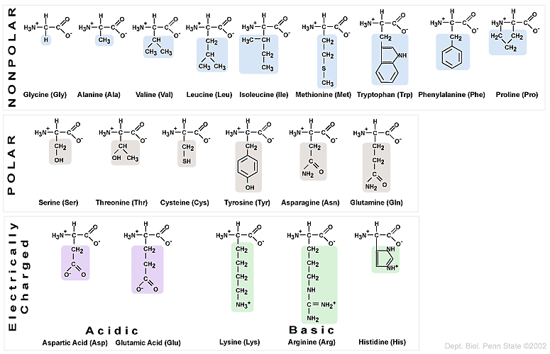
- There are 20 common α-amino acids that occur in most proteins.
Negatively Charged
Positively Charged

(Proteins 2004)

Proteins possess four levels of structure.
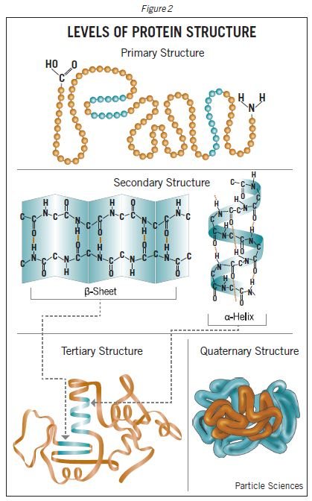

(Particle Sciences 2009)

- Primary structure
This is the specific linear sequence of the individual α-amino acids in the protein.

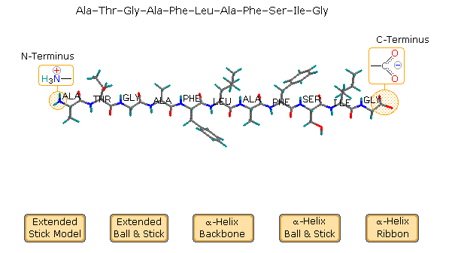

(Reusch 2013)
- Secondary structure
The regular arrangements of the various sections of the protein which depend on hydrogen bonding present. Two common protein secondary structures are:

  - α-helix – interactions within the peptide chain. Hydrogen bonding occurs between a lone pair of electrons from the oxygen in the carbonyl group and the polar hydrogen atom of an amine group. The amine group interacts with the carbonyl group of a peptide bond four amino acids away from it. This produces a right-hand coiled helix.

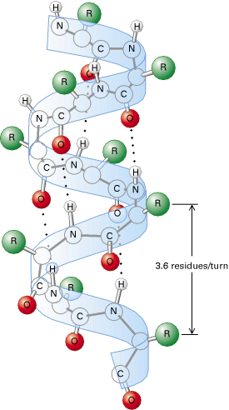

(Cruz 2011)

  - β-pleated sheets – interactions between adjacent polypetides. Polypeptides line up alongside one another (either the same protein chain or a different protein chain) and hydrogen bonding forms between closely placed oxygens in a carbonyl group and the hydrogen in an amine group. This results in hydrogen bonds within the plane of the sheet structure. All amino groups and carbonyl groups are involved in hydrogen bonds in β-pleated sheets.
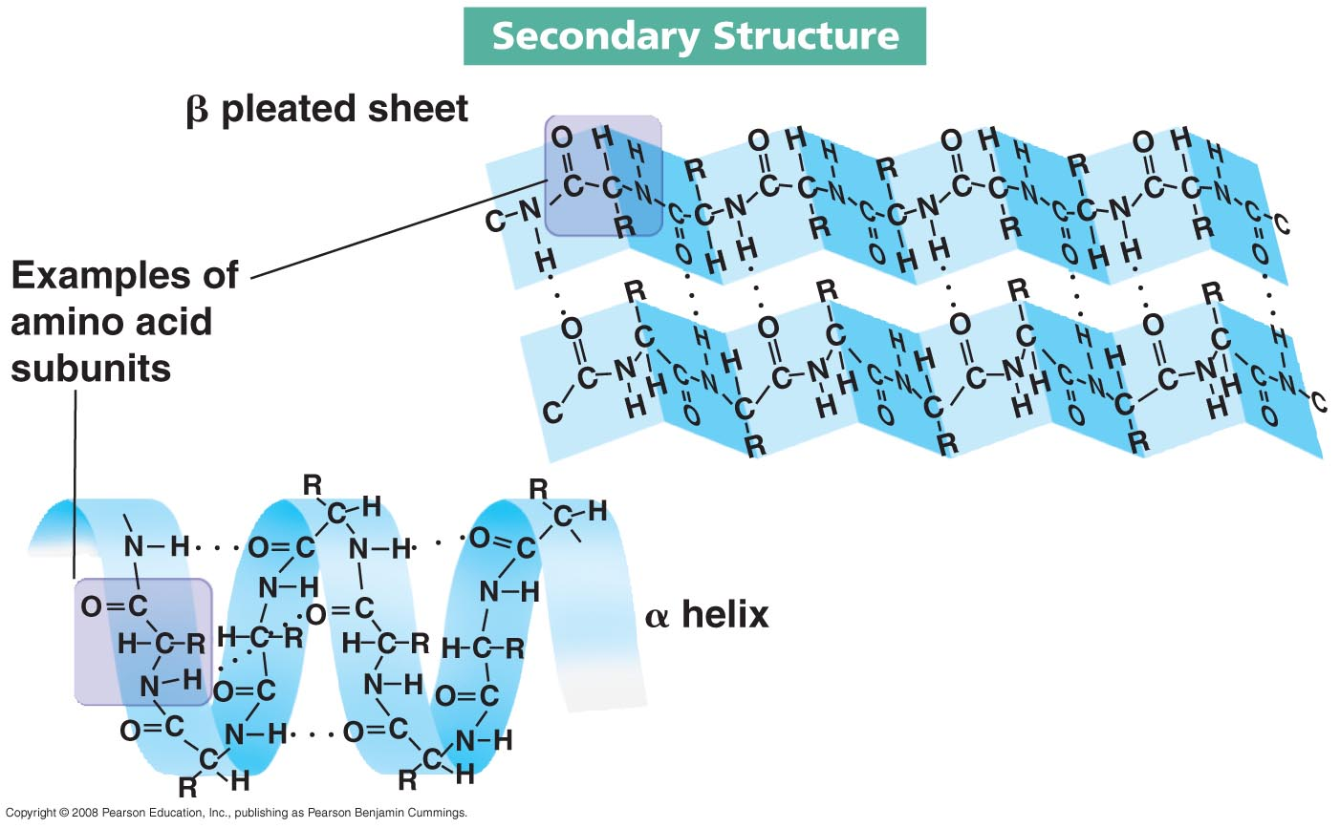

(Kimberley 2013)

- Tertiary Structure – interactions that occur between the side chains of the α-amino acids in the proteins. These may include hydrogen bonding, ionic bonding, dipole-dipole forces, covalent bonding and/or dispersion forces. The protein molecule will bend and twist in such a way as to achieve maximum stability.

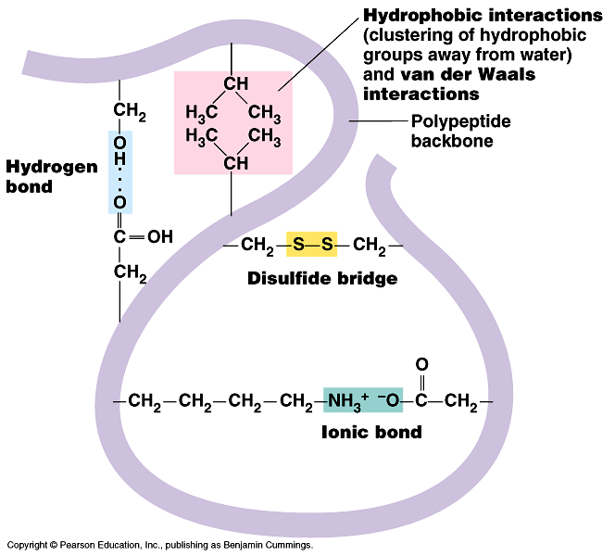

(Adam-Day 2015)

In an aqueous environment, the protein will orient itself such that the hydrophobic side chains are oriented inwards and the hydrophilic side chains are oriented outwards.

Disulfide bridges are covalent in nature and are produced through the oxidation (loss of hydrogen) of two cysteine α-amino acids in the protein.

The structure and function of a protein is most dependent on its primary structure. This determines the nature of its most stable secondary and tertiary structures.

- Quaternary structure – this involves multiple proteins interacting to form larger conglomerate proteins.

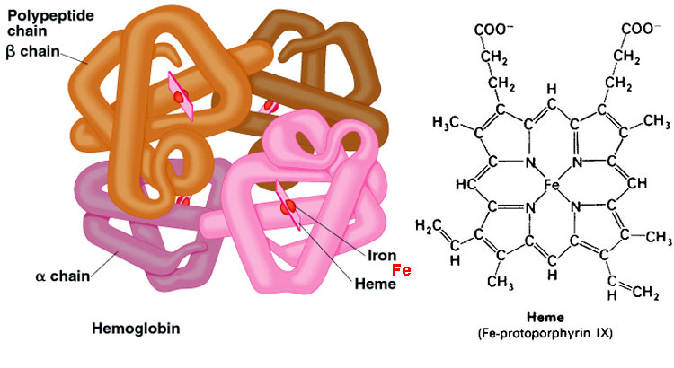

(Proteins and Amino Acids 2013)

The Protein Data Bank (PDB)
- Online archive of macromolecular structural data. It is now overseen by the Worldwide Protein Data Bank (wwPDB) organisation and has four member organisations from USA, Japan and Europe.
- wwPDB was formed to formalise and standardise the presentation and annotation of protein structural data. The data is freely accessed by anyone and allows collaboration and communication between scientists all over the world.
- Each PDB entry contains information about the primary, secondary, tertiary and quaternary structures of a protein.

Complete Lucarelli Set 20 Polymers, Polypeptides and Proteins

Bibliography
Adam-Day, Sam. 2015. "A Level Notes." Protein Structure. Accessed June 6, 2016. http://alevelnotes.com/protein-structure/61.
Creative Commons Attribution-NonCommercial-NoDerivatives 4.0 International License. 2014. "A Brief Guide to the Twenty Common Amino Acids." Compound Interest. September 16. Accessed June 6, 2016. http://www.compoundchem.com/2014/09/16/aminoacids/.
Cruz, Wilhelm. 2011. "Peptide Bonds and Protein Structure." Washington University in St. Louis. Accessed June 6, 2016. http://www.nslc.wustl.edu/courses/bio2960/labs/02Protein_Structure/PS2011.htm.
Ehingers, M. 2014. "How Organic Chemistry Recations Work." Magnus Ehingers Teaching. January 13. Accessed June 7, 2016. http://ehinger.nu/undervisning/index.php/starta-haer/nyheter/1249-avd-f-kemiska-fanigheter/5959-avd-f-kemiska-fanigheter-del-20-hur-sker-organiska-reaktioner.html.
Helmenstine, A.M. 2015. "Chemistry Jokes and Puns - With Explanations." About Education. October 24. Accessed June 7, 2016. http://chemistry.about.com/od/chemistryjokes/ss/Chemistry-Jokes-and-Puns-With-Explanations.htm#step1.
Iveson, J. n.d. "Amines, Amides and Heterocycles. ." Slide Player. Accessed June 2, 2016. http://slideplayer.com/slide/4214444/.
Ju. 2010. "N-Terminus." Wikipedia. August 27. Accessed August 2, 2018. https://en.wikipedia.org/wiki/N-terminus.
Kimberley. 2013. "Biochem Rocks." Amino Acids and Proteins Part 2. February 26. Accessed June 6, 2016. https://kimberlybiochemist.wordpress.com/2013/02/26/.
Larsen, D. n.d. "Noncovalent Interactions Between Molecules." UCDavis Chemwiki. Accessed June 1, 2016. http://chemwiki.ucdavis.edu/Textbook_Maps/Organic_Chemistry_Textbook_Maps/Map%3A_Organic_Chemistry_(McMurray)/Unit_02%3A_Polar_Covalent_Bonds%3B_Acids_and_Bases/2.12_Noncovalent_Interactions_Between_Molecules.
Moffit, M. 2012. "Asap Science." Twitter. May. Accessed June 7, 2016. https://twitter.com/asapscience/status/721458193172271105.
Particle Sciences. 2009. "Protein Structure." Particle Sciences. Accessed June 6, 2016. http://www.particlesciences.com/news/technical-briefs/2009/protein-structure.html.
2004. "Proteins." Basic Chemistry. Accessed June 6, 2016. http://www.personal.psu.edu/staff/m/b/mbt102/bisci4online/chemistry/chemistry8.htm.
2013. "Proteins and Amino Acids." aberdeenc. February 18. Accessed June 6, 2016. https://aberdeenc.wordpress.com/2013/02/18/proteins-and-amino-acids/.
Reusch, William. 2013. "Peptides and Proteins." Natural Products. May 5. Accessed June 6, 2016. https://www2.chemistry.msu.edu/faculty/reusch/virttxtjml/protein2.htm.
Sepe, Michael. 2012. "Denisty and Molecular Weight in Polyethylene." Plastics Technology. June. Accessed June 7, 2016. http://www.ptonline.com/columns/density-molecular-weight-in-polyethylene.
Swimm, Alison. n.d. "Science Fun." Pinterest. Accessed June 7, 2016. https://au.pinterest.com/pin/175851560422914032/.
Yuku. 2013. "Survivorsucks." Survivorsucks. February 18. Accessed June 7, 2016. http://survivorsucks.yuku.com/topic/102810/Stephen-hate-thread?page=4#.V1Z3rzV97IU.

